PET SPEAKING GUIDE

Esercitazioni per Part 1 dell’esame.

Nella prima parte l’esaminatore ti chiederà
domande di tipo individuale su argomenti che riguardano la tua vita, Il tempo libero gli hobby ,gli studi, la musica , lo sport. Sono comprese anche domande sul presente, passato e futuro.

Esempio di domande

What’s your name?

Where are you from?

------------------------------------------------------

What do you do

Do you work or are you a student in…..
(Have you got a job? /what job do you do/
What subjects do you study)

Do you enjoy studying English?Why?
Do you think English will be useful for you in the future?

What did you do yesterday evening /last weekend?

What do you enjoy doing in your free time?

In questa fase dell’ esame ti sarà chiesto lo spelling . Bisogna esercitarsi con parole in inglese fino a saper ripetere le lettere dell’alfabeto facilmente.
Esegui i seguenti esercizi :
http://www.youtube.com/watch?v=jaHvC_qtT8s
http://a4esl.org/q/j/ck/mc-spelling.html
http://esl.about.com/library/listening/bllis_beg_spelling.htm

Part 2
Nella seconda parte l’esaminatore da una illustrazione e propone un argomento. I candidati devono discutere ogni singolo oggetto presente nella scheda per arrivare ad una decisione con l’altro candidato.
La scelta e la soluzione finale deve avere d’accordo entrambi gli studenti.
Esercizio
A lawyer has a room where people wait. It’s not very comfortable. Talk about the different ways to make the room more comfortable and say which would be best.

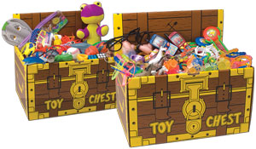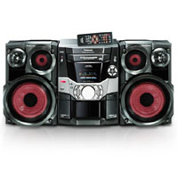



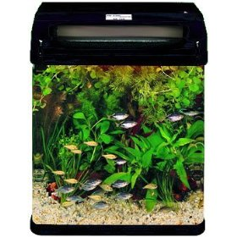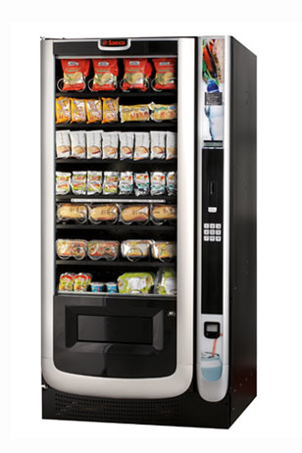
Per questa prova bisogna dare suggerimenti, discutere alternative, dare consigli,per arrivare ad una scelta finale in accordo con l’altro studente.
Strategie
Alla consegna bisogna stabilire chi è coinvolto:
a)voi b) un’altra persona c)un ente astratto
E’ importante stabilire questo per usare il pronome soggetto più appropriato
La situazione descritta è direttamente rivolta a te o ad una terza persona?
Se è terza persona usa he or she o se un ente astratto they
Consigli:
- non sprecare tempo nel dare informazioni inutili.
- dai ragione alle tue idee
- Fai in modo che il tuo partner può intervenire : coinvolgilo non dominarlo!

Alcune espressioni e funzioni linguistiche da poter utilizzare.
chiedere un opininione  Con domande brevi  I didn’t like that film.Did you?  I wouldn’t do that again.Would you?  Dare un opinione | - do you like?  - how do you like  - how do you feel about that  - what’s your opininion about  I think/ I don’t think  Personally , I think is a terrible idea  In my opinion I think
Fare proposte | Let’s go fora walk  Shall we go for a walk?  Why don’t we go for a  Walk  What about/ how about going for a walk  It would be a good idea
Discutere un’alternativa | Which do you think is best?  Its difficult to decide but…..  I think it is more useful because….  It would be better to go….
Accettare  Rifiutare | Yes , you are right  I agree with you  I completely agree  You could be right  Definitely  Sure  I cant agree with that  In my opinion is quite wrong  I don’t really agree with you about that
Esprimere preferenze | I’d rather go to campsite  I’d like to stay  I’d prefer to go

Utilizzando le frasi su indicate scrivi un dialogo sulla situazione su indicata

Part 3
Nella terza parte lo studente deve descrivere
Individualmente una foto colorata per circa un minuto
Una buona descrizione deve includere:la gente , il luogo,le azioni, l’ambiente.
Frasi utili
1)Introduzione
Frasi utili
In this photo I can see…..
The photo shows…….

2)Descrivere dove sono le immagini
•foreground
• background
•in the upper part
•in the lower part
•in the left part
•in the right part
•in the central part
•in front of
• behind
• next to …
• on the right
• on the left
•in the middle
•from front
•from behind
•from above
•from below
•the second from left/right

Esempio
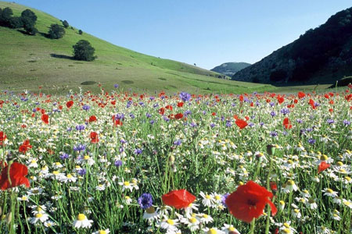
What is where?
In the background
In the foreground

In the middle


On the top
At the bottom

2)Parlare delle persone nella foto e descrivere
a)Cosa stanno facendo
They are talking in a pub
The woman is typing a letter
The girl is sitting next to her friend

b)Chi sono
She’s probably a teacher
She is an actress
They are a family

c)Dire l’età
He is about 50
She is in her twenties
He is a child/kid/teenager/young/middle-aged

d)Cosa sentono
They look bored /happy/worries
They seem they are enjoying

- Cosa indossano
He is wearing a red tie
She is wearing a flowery dress
E’ importante saper gestire la descrizione anche quando non si ricorda una parola. A questo punto lo studente non si deve bloccare
Stategie utili
- it’s someting for
- It’s a kind of
- It’s a shop where you can buy fish(a fishmonger’s)
- It’s someone who helps people in the hospital(nurse)

Lo studente deve interpretare ciò che vede nella foto , non fare
affermazioni
It might be summer
They could be tourists
They seem
It is probably
Perhaps
Esercitazioni:

The English Experiment: Exam tips: how to describe a picture
theintermediate2experiment.blogspot.com/.../e...

Describing a picture - English
www.tolearnenglish.com/.../exercise-english-91... -

Part 4

In questa parte lo studente deve discutere e dare opinioni su ciò che piace o non piace,preferenze, esperienze o abitudini
Esempi di consegna

Your picture showed people people taking photos. Now, I’d like you to talk about the things
you like to take photos of and say when you like to take them.

Your photographs showed people visiting towns. Now I’d like you to talk together about things you like to do when you visit a town and say why you like to do them

Strategie
1)Spiegare il proprio punto di vista
· I love/quite like/really enjoy/don’t
like/hate camping because …
· I find (don’t find) visiting museums quite
boring/exciting/expensive/relaxing …
· I’m (I’m not) very interested in / quite
keen on sport …..
because …

2)E’ fondamentale coinvolgere l’altro studente nella conversazione
What do you think?
What is your opinion of?
How do you feel about going?

3)Mostrare coinvolgimento
Oh,I see
That’s interesting
Yes,hmm
Right

- Fare domande per ampliare il discorso
Fencing?Is it very difficult
What kinds of TV programmes do you like watching at?
Really?Why?
When was the last time you went to?

Esercizi utili per Part.3

Ci sono alcuni verbi che vengono usati male.
Complete the sentence with the correct verb from the box
1.Completa le frasi con do or make
1.Remember to …….an appointment to the dentist.2 Can you…….Me a favour.3If you want to keep fit, you should do….. some exercise every day.4.I’m not good at Maths and I’m not………Much progress. 5.Your test isn’t very good ,George. You’ve…….a lot of mistakes.

CONFUSING WORDS: anche le parole sotto in grassetto spesso vengono usate male.
Scegliete la parola giusta in ogni frase.

a. What are you going to wear / dress for the party next weekend?

b. Oh no! I’ve worn /put on someone else’s jacket!

c. Do you think I should wear a dress / dressed or a suit to the ceremony?

d. Don’t come in! I’m not put on / dressed!

e. She’s dressing / wearing a red suit today.

TYPICAL ERRORS:
in questo brano ci sono cinque errori di grammatica che capitano spesso. Solitamente sono la 3° persona del singolare, la ‘s’ finale dei plurali, la concordanza tra soggetto e verbo, la forma dei tempi composti (come il Present Continuous). Trovateli e correggeteli.

This picture show a family in your living room. The children are sitting on the floor and the parents are sitting on the sofa. The children is watching a cartoon on TV – I think they’re enjoying it. The boy’s laughing. The father is read a magazine, but he doesn’t look very interested. The mother reads a book, maybe it’s a novel, I’m not sure.

1) LIKE / DISLIKE: trovate e correggete 5 errori in questo brano.
In my free time I enjoy do sport. That’s my favourite activity. I go swimming twice a week, to keep fit, and I also really like played football. I’ve been keen on to play football since I was small and I always playing on Sunday morning with my friends. I’d like playing more often, but I can’t, because I haven’t got enough free time.
2) AVVERBI: inserite l’avverbio al punto giusto nella frase.

a. I like horse riding. (quite )

b. My sister enjoys playing role games. (very much)

c. John’s interested in ethnic music. (very)

d. I hate cooking. (really)

e. We’re keen on sailing. (quite)

f. I’m not interested in watching TV. (very)

g. I don’t like driving. (very much)

h. Susan’s not keen on studying. (very)

Per il glossario PET digitare
[PDF]

PET Vocabulary List

